Big Mountain Resort

# Introduction

Big Mountain Resort (BMR), located in Montana, was opened 72 years ago. It has a skiable terrain of 3,000 acres divided into 4 terrain parks and 600 acres available for night skiing. Beyond the 333 mm average snowfall, there are 600 acres served by snowmaking. The peek is 6.817 ft high, and the base is at 4.464 ft resulting in a vertical drop of 2.353 ft. The lift facilities are 3 fast Quads, 2 Quads, 6 triples, and 3 surface, totaling 14 chairs for the 105 trails in total and the longest trail running for 3.3 miles. Last year the Resort operated for 123 days and received 350K visitors. The current season is expected the same number of open days and visitors count.

The Resort added a new operational expense by installing the new lift. Therefore, we reviewed the pricing strategy to cover the added cost and checked the price elasticity to maximize the returns.

The relevance of all the facilities and the competitors' pricing was considered while developing the new price strategy to increase the confidence in the correct pricing decisions to support future facility investment plans based on projected revenue.

# Data Wrangling

The data available considered BMR facilities and characteristics and the competitors' info totaling 27 features of 330 resorts. Checking the data completeness, we had over 50% of the fast eight information missing, 43% of night skiing, and 16% of the ticket value.

Our target was the Adult Weekend price, currently at $81. We selected the Weekend price because it has fewer missing rows and imputed those missing values with the Weekday prices when it was available. Rows without both ticket prices were removed, totaling 277 entries on the final dataset.

Data cleansing was performed, but the information necessary to fix the existing issues was available online or were obvious typos such as the outliers for "Opening Year" or "Skiable Terrain." Therefore, the column "fastEight" was removed entirely (just one value different from zero).

Most of the resorts are in New York state, but resorts are all over 38 regions and 35 states. The ticket price distribution showcases that the price ticket is related to the geographical location of the Resort. BMR ticket of $81 is an outlier for Montana; however, it is an average price compared to alternatives of other states with equivalent facilities and options.

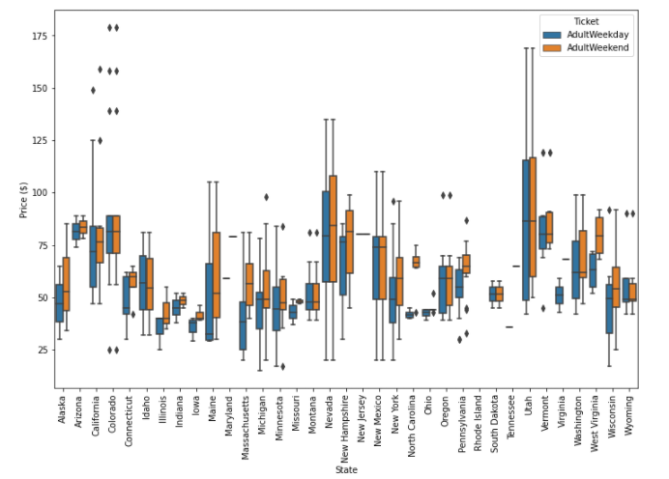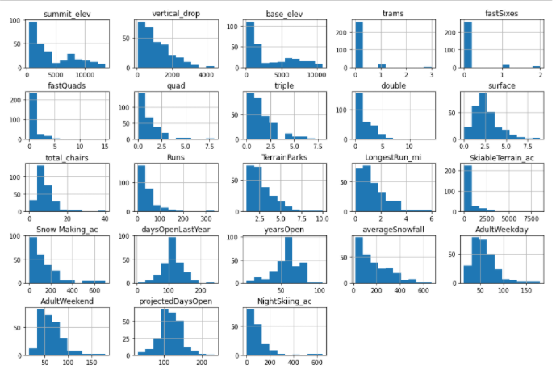

# Exploratory Data Analysis

We explored the 22 numerical and 3 categorical features and their correlation to the price. For example, New York has most of the resorts, but they are smaller, while Montana has the 4th largest skiable area in the country, but it is not populous.

Principal Component Analysis (PCA) showed that two components handle 75% of the variance, and if we consider 4 features, we have 95% of the price variance. However, they don't reveal any pattern when you do a scatterplot.

We can use all the states to model our price because there is no clear pattern for the pricing and the States.

We created ratio metrics related to the business and performed a correlation analysis. Features such as vertical drop, fastQuads, Runs, Snowmaking_ac, and total_chairs strongly correlate with the price. In addition, the night skiing area is related to regions densely populated. From the calculated ratios, resort_night_skiing_state_ratio is the most correlated.

# Modeling

We assessed a linear model and a random forest model to predict the ticket price during the modeling. We imputed the missing values with the median and mean values of the metric and compared the results. Using the StandardScaler we scaled all metrics to have an average value of zero and a unit variance. After this treatment, data was split as 70% training set and 30% for the testing set.

The most relevant features modeling the ticket price for both models were vertical drop, snowmaking area, number of runs, and fast quads. The random forest's mean absolute error (MAE) for the test set was $9.65, outperforming the linear regression model, which had MAE equal to $11.79, an error almost $2 smaller.

BMR's current ticket price is $81.00. However, based on the facility features of BMR, the model predicts that it should be charging $95.87. So even considering the model error of $10.39, Big Mountain Resort can charge more for their tickets.

Four scenarios were evaluated using the trained models to verify the impact of facility changes on the price and consequent revenue estimation, assuming no changes in the annual number of visitors and days per visitor with 350,000 visitors x 5 tickets/visitor.

### 4.1. Permanently close to 10 of the least used runs. This doesn't impact any other resort statistics.

* Adopting this strategy, the model suggests a ticket price drop of $1.81 for an annual revenue decrease of about $3.2M. The relation between the number of closed runs and the revenue is not linear. Still, if we consider a linear relationship, which is somewhat reasonable, we will have a revenue decrease of about $0.32M for each closed run.

### 4.2. Increase the vertical drop by adding a run to a point 150 feet lower down but requiring the installation of an added chair lift to bring skiers back up without more snowmaking coverage

* This change supports an increase of $1.99 on the ticket price, generating an extra annual revenue of $3.5M.
* This revenue is enough to cover the added lift's reported annual operating cost of $1.54M.

### 4.3. Same as (4.2), but adding 2 acres of snowmaking cover

* From scenario 2, we have a ticket price increase of $1.99.
* Only 2 acres of additional snowmaking cover does not justify other changes in the ticket price. If scenario 2 requires such a feature, the operational costs must be evaluated.

### 4.4. Increase the longest run by 0.2 miles to boast 3.5 miles length, requiring additional snowmaking coverage of 4 acres

* The longest run length is not a relevant feature of the model, so the proposed extension of the run-length does not result in a higher modeled ticket price to justify the expenses related to such addition.

# Conclusion

Reviewing all the data available and the model results for all the scenarios, only scenario 2 corroborates a price increase, and the new lift was recently installed. Therefore, a price increase of $1.99 or more is reasonable.

An operational cost evaluation is mandatory for any change in the scenario above to assess the practical revenue impact. The current price is undervalued, and scenario 1 of closing runs can be applied. Still, an on-time assessment of the customer satisfaction and overcrowding effects must be monitored, and this process can be done one run each time.

## Details and future work

The availability of revenue data was related only to the tickets price. However, other facilities' revenue, such as hospitality, food, and beverage, could improve the model performance. Also, if the operational cost of each facility was available, all the scenarios could be evaluated with more accuracy.

Model quality is a direct consequence of the quality of the data available to the model. So other key features that were not present in the data source will restrain the model applicability. For example, the customers will need accommodation facilities for multiple-day trips that the Resort could provide. The Resort should be close to an urban center capable of supplying these services.

A permanent tracking of the Resort's metrics could help any prompt decisions, so a dashboard of all metrics must be considered. The dashboard also can help to enforce the culture of data-driven decisions.